The Wrong Politics: How Welfare Institutions Sort Economic Disruption into Solidarity or Scapegoating
Ben Smart
University of Copenhagen

Abstract
Why does economic disruption so often produce political responses that fail to serve the interests of those experiencing it? Workers displaced by automation disproportionately support radical right parties whose programmes deepen their precarity, oppose the redistributive mechanisms that would most directly address their material situation, and blame immigrants rather than structural change for their declining prospects. This paper argues that welfare institutions are central to explaining this pattern — not as buffers that moderate the intensity of backlash, but as sorting mechanisms that determine its direction. Drawing on evidence from the European Social Survey across 34 countries, I show that the relationship between automation exposure and anti-immigration attitudes varies systematically by welfare institutional context. Using the Comparative Welfare Entitlements Dataset, I find that welfare state generosity — measured by decommodification — accounts for 72 per cent of the cross-national variation in how strongly automation exposure converts into exclusionary attitudes (r=-0.848, p<0.001). At the individual level, a one-standard-deviation increase in welfare generosity reduces the marginal effect of automation exposure on anti-immigration sentiment by 0.056 scale points (p<0.001, N=81,885). Crucially, this finding emerges only when welfare is measured by its decommodifying quality rather than by crude spending levels — active labour market policy spending shows no buffering effect, consistent with the theoretical argument that what welfare communicates about recipients’ worth matters more than how much is spent. The paper synthesises previously isolated mechanisms — identity switching (Bonomi et al. 2021), misattribution (Gallego and Kurer 2022), and defensive othering (Wagner 2022) — into a single institutionally-mediated causal chain, proposing that the welfare state determines whether this cascade activates by shaping how economically disrupted individuals understand themselves.

I. Introduction
Since the seminal contributions of Autor, Levy, and Murnane (2003) on the task-based framework and the subsequent empirical literature on the political consequences of routine-biased technological change, a robust finding has emerged across comparative political economy: workers in routine-task-intensive occupations — those most exposed to automation — disproportionately support populist radical right parties (Gingrich 2019; Kurer 2020; Im et al. 2019; Autor et al. 2020; Gallego and Kurer 2022). This pattern holds across countries, time periods, and measurement strategies, and has been confirmed by analyses using panel data (Kurer 2020), cross-sectional surveys (Im et al. 2019), and regional-level indicators of robotisation (Frey et al. 2018; Caselli et al. 2021).
The question this paper addresses is not whether this pattern exists — it has been thoroughly documented — but why it takes the form it does. Why does economic disruption produce exclusionary politics rather than demand for redistribution? Why do people experiencing genuine material vulnerability turn against the welfare state rather than toward it? Or, put differently, why does economic disruption so often produce the wrong politics — political responses that systematically fail to serve the interests of the people experiencing the disruption?
The conventional answer from comparative political economy treats the welfare state as a buffer that moderates the intensity of political backlash. Building on Ruggie’s (1982) framework of “embedded liberalism,” this literature conceptualises welfare spending as a compensatory mechanism: more generous provision reduces the economic insecurity that fuels populist support, while insufficient compensation leaves insecurity unaddressed, producing stronger backlash (Vlandas and Halikiopoulou 2022; Colantone and Stanig 2018). The operative variable is the quantity of compensation. The policy implication follows directly: spend more, get less populism.
In contrast to this framework, I argue that welfare institutions function not as buffers but as sorting mechanisms — institutional configurations that determine the direction of political response to economic disruption, not merely its intensity. The same economic shock, filtered through dignity-preserving welfare institutions, can produce demand for solidarity and structural reform. The same shock, filtered through stigmatising, conditional institutions, produces othering, scapegoating, and what Busemeyer, Rathgeb, and Sahm (2023) term the “particularistic-authoritarian” turn. The welfare state, in this telling, does not simply stand between economic disruption and political backlash. It actively shapes what the political response is.
More specifically, I propose that welfare institutions mediate between economic disruption and political behaviour by shaping the self-concept of economically vulnerable individuals — their understanding of their own worth, their citizenship status, and their position relative to other groups in society. When welfare design preserves the self-concept through universal provision and dignity-affirming implementation, disruption can be processed through class identity, producing demand for redistribution and collective response. When welfare design damages the self-concept through stigmatising conditionality, surveillance-based implementation, and institutional communications that frame economic need as moral failure, disruption activates a cascade of identity switching (Bonomi, Gennaioli, and Tabellini 2021), misattribution (Gallego and Kurer 2022), and defensive othering (Wagner 2022; Patrick 2016) that produces exclusionary politics.
The paper makes three contributions. First, it connects these previously isolated micro-mechanisms into a single causal chain, identifying the welfare state as the switching variable that determines whether the chain activates. Second, it extends the framework of Ballard-Rosa, Jensen, and Scheve (2022), who establish that economic decline activates social identity processes producing authoritarian values, by theorising the upstream institutional conditions under which that identity activation occurs. Third, it provides cross-national empirical evidence that the conversion of automation exposure into exclusionary attitudes is powerfully moderated by welfare state decommodification — and that this moderation is invisible when welfare is measured by spending levels rather than institutional quality, a finding that directly challenges the buffering model’s reliance on generosity as the operative variable.
The paper proceeds as follows. Section II establishes the empirical failures of the buffering model. Section III develops the theoretical argument: the sorting mechanism, the self-concept as pivot, and the three-stage damage cascade. Section IV traces the recursive feedback loop through which punitive welfare design manufactures the attitudinal raw materials for its own delegitimation. Section V considers the counterfactual and the visibility asymmetry that compounds the sorting mechanism. Section VI presents the empirical analysis. Section VII discusses the implications.

II. The Limits of the Buffering Model
The theoretical foundation for treating the welfare state as a buffer against political extremism derives from the “embedded liberalism” bargain described by Ruggie (1982). The core logic is that democratic governments, recognising that economic openness produces losers as well as winners, provide social protection as compensation in exchange for continued public support for open markets. As Milner (2021) explains, for a long time scholars assumed that voters facing the vicissitudes of openness would demand compensation, and that this compensation via redistribution would attract working-class voters and dampen preferences for extremism. Contemporary applications test whether welfare generosity reduces radical right support: Vlandas and Halikiopoulou (2022) argue that the effect of social risk exposure on radical right voting is contingent on the generosity of social policies targeting particular risks, implying that governments can shape political outcomes through the policies they implement.
Three categories of evidence suggest this framework, while not wrong, is missing something important.
Compensation that does not work. Gallego and Kurer (2022) identify what they call a “concerning finding” from Gingrich’s (2019) comparative study — the only careful cross-national analysis assessing whether public policies aimed at alleviating labour market risks for workers affected by automation can prevent the political turn to protest voting. Gingrich finds that workers highly exposed to automation are not less likely to vote for populist parties in countries with more generous early retirement policies, more in-kind spending, or more protective labour market regulation. If the buffering model were correct, countries with more generous welfare states should show weaker automation-to-populism effects. They do not.
Compensation that backfires. Stutzmann (2025) examines Germany’s coal phase-out, a case where affected communities received substantial compensatory investment and where both compensation and interest group representation — conditions past research identifies as necessary for preventing backlash — were fulfilled. Despite maintained material conditions, affected municipalities showed higher abstention rates and lower support for the issue-owning party. Bergman (2023) theorises “self-undermining” policy feedback effects, whereby welfare interventions visibly benefiting groups that potential radical right voters view unfavourably can actually catalyse greater support for the radical right. Fetzer’s (2019) analysis demonstrates that UK welfare cuts predicted Leave support, but through the erosion of political trust and efficacy rather than through material deprivation per se.
Compensation that is resisted. Pelc (2025) demonstrates that a sizeable portion of workers resist being compensated out of work even when the compensation fully replaces their income. Workers prefer reduced hours over full unemployment at the same pay. They prefer compensation from employers over identical compensation from government. And Protestant religious affiliation predicts resistance even after a lottery windfall. The form, source, and meaning of compensation carry political weight independently of their material content. As Guriev (2024) observes, compensating the losers of economic transformation has proven much harder than economists assumed — not because of insufficient resources, but because of political and institutional constraints that the buffering framework does not theorise.
What these findings share is an implication: the political effects of welfare institutions are not reducible to their spending levels. Something about how welfare operates — what it communicates, whose identity it affirms or degrades, what moral frameworks it installs — determines whether economic disruption is metabolised as solidarity or backlash.

III. The Sorting Mechanism

A. The Self-Concept as Pivot
The central theoretical claim of this paper is that welfare institutions mediate between economic disruption and political response by shaping the self-concept of economically vulnerable individuals — their understanding of their own worth, their position in the social hierarchy, and their relationship to other groups. This self-concept, I argue, determines which of several possible political responses to disruption gets activated.
The formulation draws on Banerjee and Duflo’s (2019) argument that the goal of social policy in times of economic change is to help people absorb shocks without allowing those shocks to affect their sense of themselves. I take this literally as a causal hypothesis: when welfare institutions preserve the self-concept — communicating that economic disruption reflects a structural challenge warranting collective response — disruption can be processed through class identity and solidarity. When welfare institutions damage the self-concept — communicating that recipients are objects of suspicion whose economic position reflects moral standing — disruption triggers a cascade that produces exclusionary politics.
Welfare institutions shape the self-concept through two channels.
The implementation channel operates through direct recipient experience. Soss (1999) demonstrates that different welfare programmes create fundamentally different “learning environments”: programmes with respectful implementation foster civic engagement, while programmes characterised by surveillance and conditionality generate alienation. Wagner’s (2022) research provides the most direct evidence: welfare recipients learn and mirror the recognition norms the state enacts on them. Recipients of conditional welfare adopt narrower deservingness conceptions; recipients of enabling welfare show more inclusive attitudes. De Blok and Kumlin (2022) add that procedural fairness matters most for “losers” — fair treatment preserves institutional trust even when outcomes are unfavourable, meaning implementation quality is most consequential precisely for those already economically vulnerable.
The visibility channel operates through the “submerged state” (Mettler 2011) — tax expenditures and indirect benefits serving middle and upper-income groups that remain invisible as government assistance. Recipients of submerged welfare attribute their security to personal merit. Recipients of visible welfare are marked as dependents. This asymmetry produces a political identity fracture: a large share of the population benefits from the welfare state without recognising it, developing meritocratic beliefs structurally at odds with solidarity.

B. The Damage Cascade
When welfare institutions damage the self-concept, three mechanisms activate in sequence.
Stage one: identity switching. Bonomi, Gennaioli, and Tabellini (2021) model how individuals switch from class to cultural identity when class identity is degraded by economic disruption. Under cultural identity, redistribution demand decreases and cultural conservatism intensifies. The welfare state enters at a specific point: by degrading class identity through stigmatising implementation, conditional welfare accelerates the switch. A worker who enters a system treating retraining as a citizenship right retains class identity; one entering a system of means-testing and surveillance has that identity doubly damaged.
Ballard-Rosa, Jensen, and Scheve (2022) provide the downstream evidence: economic decline activates social identity processes producing authoritarian values through group status threat. I propose that welfare institutional mediation is the missing upstream variable — determining whether the identity activation they document actually fires.
Stage two: misattribution. Under cultural identity, economic grievances get attributed to cognitively available scapegoats. Gallego and Kurer (2022) identify three factors: psychological gratification from blaming outgroups, political supply of anti-immigrant narratives, and automation’s gradual invisibility. Wu (2022) confirms empirically that workers at higher automation risk oppose immigration but show no different technology preferences. I suggest the welfare state’s role operates through attributional frameworks: Alesina and Angeletos (2005) show that conditional systems produce individual attributions, predisposing people to look for someone getting something undeserved rather than for structural explanations.
Stage three: defensive othering. Patrick (2016) documents UK benefit claimants shoring up their own deservingness through critique of those below them — using the same criteria the welfare system applied to them. Wagner (2022) calls this “kicking down” and documents its institutional origins. Im and Komp-Leukkunen (2021) connect it to automation: routine workers support strict conditionality not from material self-interest but because it maintains status distance from groups below them. As Häusermann, Kurer, and Zollinger (2023) find, conservative-authoritarian voters are typically “a few rungs up” from the bottom — close enough to feel the proximity as a threat.

IV. The Recursive Loop
The cascade forms a self-sustaining system. Conditional welfare damages self-concepts. Damaged self-concepts produce othering. Othering generates public attitudes supporting further conditionality. Political entrepreneurs respond with welfare chauvinism. Further conditionality deepens the damage.
Haugsgjerd and Kumlin (2020) demonstrate this with panel data: poor welfare performance reduces political trust, and reduced trust makes future evaluations more negative — a “downbound spiral.” Van Hootegem, Abts, and Meuleman (2021) identify the paradox: the most vulnerable simultaneously support redistribution in principle and distrust the welfare state in practice. This gap is the space the radical right occupies.
The loop makes the damage self-concealing. Because the welfare state produces the attitudes that legitimate its retrenchment, each iteration appears more natural. Preferences that are outputs of policy appear as inputs. This is policy feedback running backwards — not Pierson’s (1994) positive feedback creating supportive constituencies, but the reverse: creating constituencies opposing the mechanisms that would serve their interests.
The cascade produces Busemeyer et al.’s (2023) “particularistic-authoritarian” welfare preference: pro-workfare, anti-poor, anti-social-investment — the programme of the radical right, generated in part by the welfare institutions it claims to oppose.

V. The Counterfactual and Its Complications
Wagner (2023) documents an “upward spiral” of solidarity among recipients of social investment policies. Rothstein (2001) shows universal programmes build social trust. Larsen (2008) shows they produce inclusive deservingness narratives. Häusermann (2024) argues that extensive universal provision conveys recognition beyond material security, diminishing zero-sum status perceptions.
A scope condition: the sorting mechanism does not operate on a blank slate. Pelc’s (2025) finding that Protestant work ethic predicts compensation resistance independently of material incentives suggests some attitudes exist prior to institutional contact. The welfare state shapes moral frameworks, but it also inherits them.

VI. Empirical Analysis

A. Data and Measurement
The analysis uses the European Social Survey (ESS), rounds 6–9 (fieldwork 2012–2018), covering 34 countries and 188,764 observations.
Automation exposure is measured by routine task intensity (RTI) scores mapped to three-digit ISCO-08 occupation codes following Autor, Levy, and Murnane (2003). Match rate: 87.8% (N=165,667).
Exclusionary attitudes are measured by a three-item anti-immigration index (whether immigrants make the country worse, undermine cultural life, or are bad for the economy; reverse-coded 0–10; Cronbach’s α=0.864).
Solidaristic attitudes are measured by a single item on whether government should reduce income differences (reverse-coded 1–5).
Welfare institutional context is operationalised in three ways. First, countries are classified into welfare regimes following Esping-Andersen (1990) and Ferrera (1996): Nordic (DK, SE, NO, FI, IS), Continental (DE, FR, AT, BE, NL, CH), Liberal (GB, IE), Southern (ES, IT, PT, CY), and Eastern (CZ, PL, HU, SK, SI, EE, LT, LV, BG, HR). Second, country-level active labour market policy (ALMP) spending as a percentage of GDP is drawn from the CPDS, matched by country and fieldwork year (22 countries, 40.7% coverage). Third, total welfare generosity from the Comparative Welfare Entitlements Dataset (CWED), measured as the mean decommodification score across unemployment, sickness, and pension programmes for 2005–2011 (15 Western European countries matched).
Controls include age, age squared, gender, education (ES-ISCED), household income decile, and urban/rural residence.

B. Empirical Strategy
The core test is a cross-level interaction:
$$Y_{\left(ij\right)}=β_{0}+β_{1}\left(RTI_{i}\right)+β_{2}\left(Welfare_{j}\right)+β_{3}\left(RTI_{i}×Welfare_{j}\right)+γ\left(X_{i}\right)+u_{j}+ϵ_{\left(ij\right)}$$
where β₃ tests whether the conversion of automation exposure into exclusionary attitudes depends on welfare institutional context. I estimate both mixed models with country-wave random intercepts and OLS with country-wave fixed effects and clustered standard errors. The cross-sectional design cannot establish causality — I test whether the pattern is consistent with the sorting mechanism and inconsistent with the simpler “more spending = less backlash” alternative.

C. Descriptive Results
Figure 2 presents the central descriptive finding. Across all welfare regimes, higher RTI is associated with more anti-immigration attitudes — the relationship is positive and significant everywhere. However, the slope is steepest in the Liberal regime (β=0.512, p<0.001), followed by Southern (β=0.462), Continental (β=0.443), Nordic (β=0.413), and Eastern (β=0.263). The Liberal regime shows the strongest conversion of automation exposure into exclusionary attitudes; Eastern Europe shows the weakest.
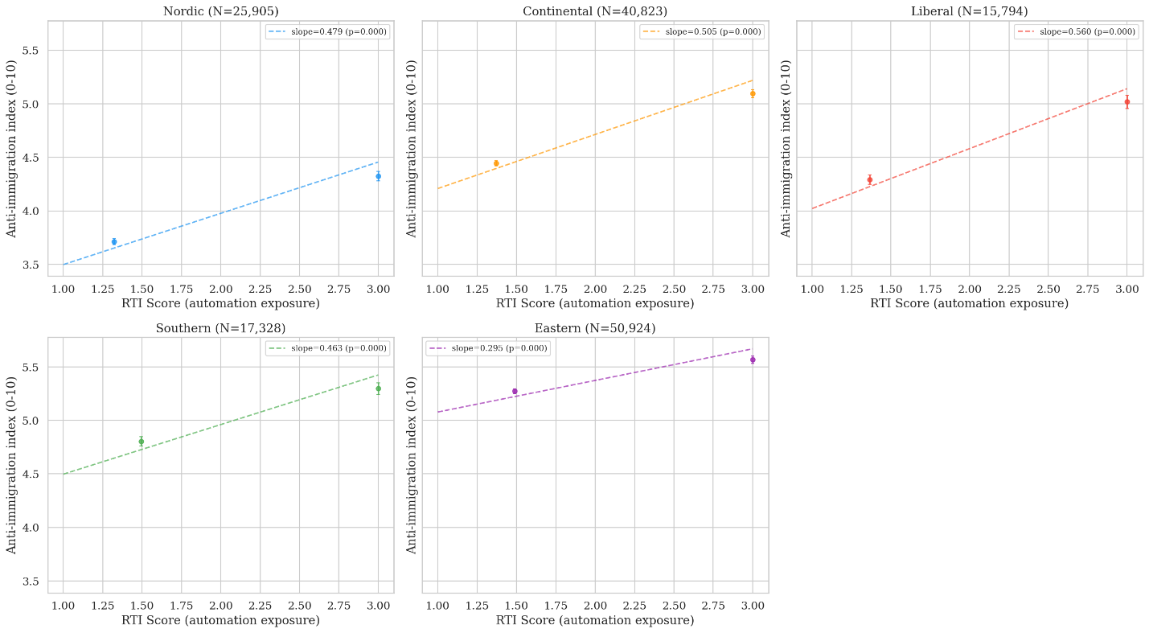

[Figure 2: RTI vs. anti-immigration by welfare regime. Five-panel binned scatter.]
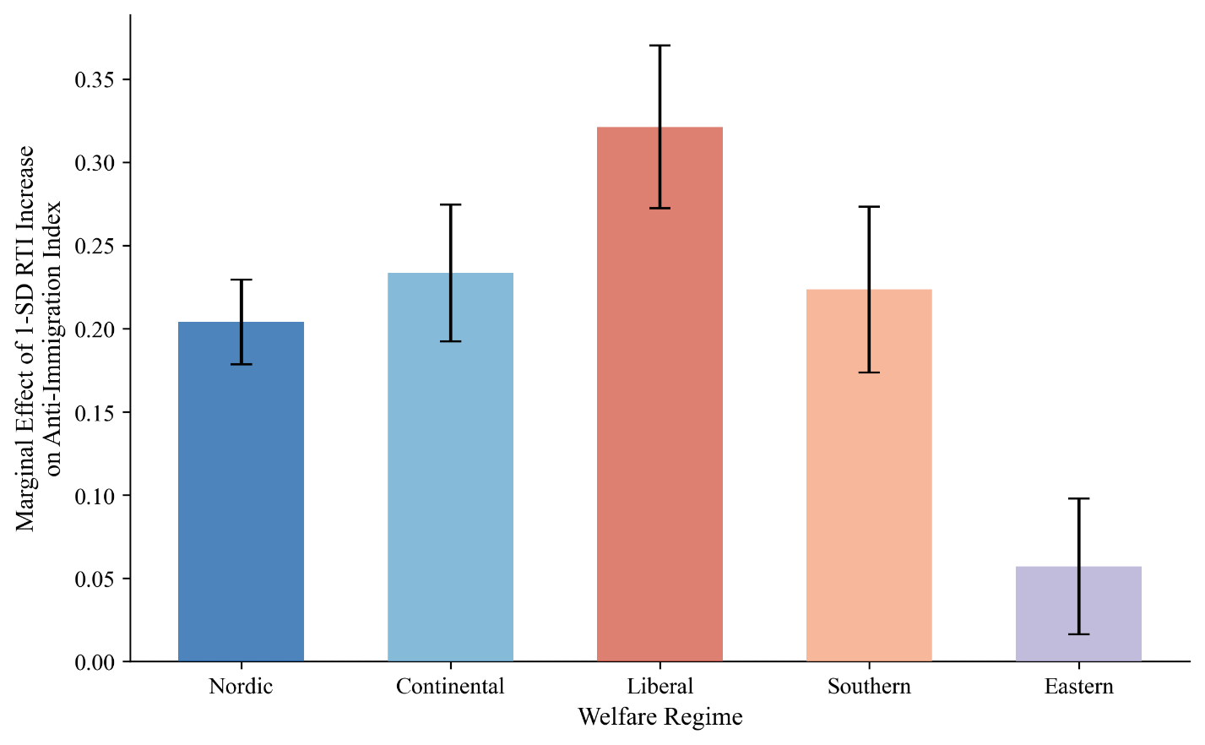

[Figure 3 Marginal effect of 1-SD RTI increase by welfare regime.]

D. Main Models
Table 2 presents the multilevel results. Model 1 (baseline) confirms that RTI predicts anti-immigration attitudes after controls (β=0.182, p<0.001, N=125,169). Model 2 introduces regime interactions with Nordic as reference:
Interaction | β | SE | p
RTI (Nordic baseline) | 0.204 | 0.013 | <0.001
RTI × Continental | 0.029 | 0.016 | 0.073
RTI × Liberal | 0.117 | 0.021 | <0.001
RTI × Southern | 0.019 | 0.022 | 0.376
RTI × Eastern | -0.147 | 0.016 | <0.001
The key result: automation exposure converts into anti-immigration sentiment significantly more strongly in Liberal welfare regimes than in Nordic ones (β=0.117, p<0.001). A one-standard-deviation increase in RTI produces 0.117 additional scale points of anti-immigration sentiment in Liberal compared to Nordic contexts, after controlling for individual characteristics.

E. The CWED Finding: Decommodification as the Operative Variable
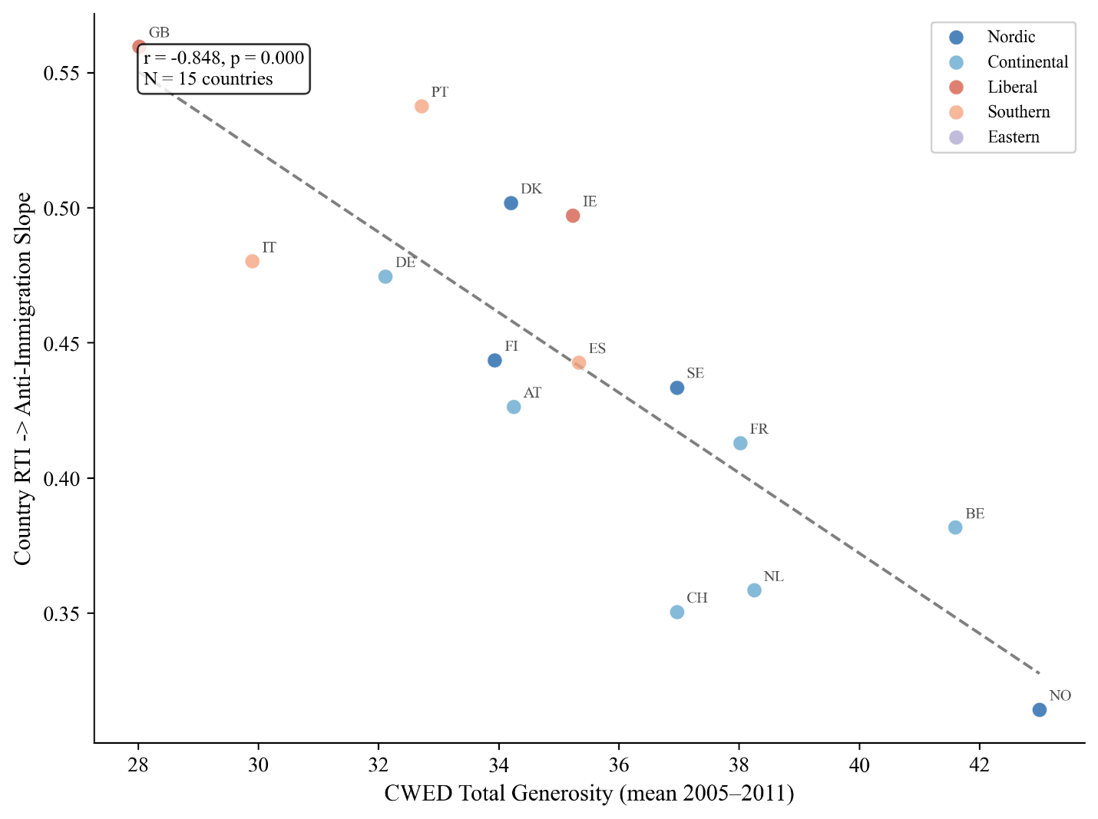
[Figure 6: CWED generosity vs. country-level RTI→anti-immigration slopes.]

At the individual level, Model 3 confirms this with the cross-level interaction:
Variable | β | SE | p
RTI | 0.216 | 0.008 | <0.001
CWED generosity | -0.069 | 0.064 | 0.281
RTI × CWED generosity | -0.056 | 0.007 | <0.001
The interaction is negative and highly significant (β=-0.056, p<0.001, N=81,885): a one-standard-deviation increase in welfare generosity reduces the marginal effect of RTI on anti-immigration attitudes by 0.056 scale points. More decommodifying welfare systems significantly buffer the conversion of economic vulnerability into exclusionary politics.

F. Education Moderation
The descriptive analysis reveals that the RTI→anti-immigration relationship is steeper for non-college workers in all regimes. In Liberal regimes, the bivariate slope drops from 0.280 (non-college) to 0.128 (college) — a 54 per cent reduction. This pattern is consistent with the theoretical prediction that education provides alternative identity resources buffering the switch from class to cultural identity.
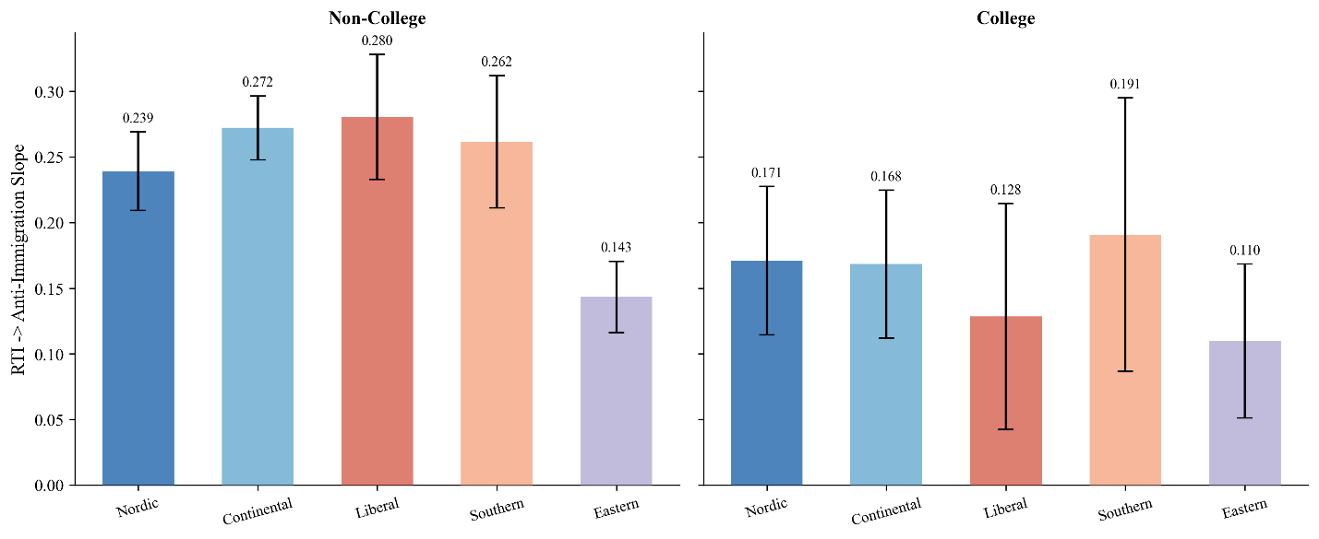
[Figure 4: RTI→anti-immigration slopes by education and regime.]
The formal three-way interaction (Model 4: RTI × regime × non-college) shows a positive

G. Redistribution and Radical Right Voting
Model 5 (redistribution) shows a weaker pattern. RTI predicts slightly more redistribution support everywhere (β=0.044, p<0.001), but the cross-regime variation does not clearly match theoretical predictions — the RTI × Liberal coefficient is small and non-significant (β=0.011, p=0.285). The institutional moderation of the vulnerability→solidarity pathway is not detectable in this data. This asymmetry is itself substantively interesting: welfare context shapes the conversion of vulnerability into exclusion more strongly than its conversion into solidarity.

H. Robustness
(β=0.116). The 95% confidence interval never includes zero in any specification.

[Figure 5: Coefficient stability across robustness specifications.]

I. Limitations

VII. Discussion and Conclusion
This paper has argued that welfare institutions function as sorting mechanisms that determine the political direction of response to economic disruption. The empirical analysis provides three pieces of evidence consistent with this argument.
First, the conversion of automation exposure into anti-immigration attitudes is significantly stronger in Liberal welfare regimes than in Nordic ones, a finding that survives all robustness specifications. Second, this institutional moderation is invisible when welfare is measured by spending levels but emerges clearly when measured by decommodification — CWED generosity accounts for 72 per cent of the cross-national variation in vulnerability-to-exclusion slopes. Third, the sorting effect is descriptively concentrated among non-college workers, consistent with the prediction that education buffers the identity-switching mechanism.
The contrast between the ALMP and CWED results speaks directly to the theoretical argument. The buffering model asks: how much does the welfare state spend? The sorting mechanism asks: what does the welfare state communicate? A country can spend heavily on active labour market policies that are punitive, conditional, and dignity-stripping — and that spending will register as “generous” in crude measures while communicating suspicion to recipients. Decommodification captures something different: the degree to which the welfare state enables citizens to maintain their living standards and, crucially, their sense of themselves without dependence on market employment. This is the institutional quality that Banerjee and Duflo identify as the goal of social policy — absorbing shocks without allowing them to affect the self-concept.
These findings bear on the scholarly debate about whether radical right support has “economic” or “cultural” roots. Ciccolini (2024) argues that this distinction is flawed because voters give a cultural reading to economic phenomena. The present paper develops this in an institutional direction: the welfare state is part of what determines whether economic disruption receives a cultural reading. The cultural backlash is not a rival explanation to the economic one — it is what economic disruption looks like when welfare institutions fail to preserve the self-concept.
The asymmetry between exclusion and solidarity findings deserves reflection. The damage mechanism — vulnerability converting to exclusion — produces clear empirical patterns. The protective mechanism — dignity-preserving welfare converting vulnerability to solidarity — produces weaker ones. This may indicate genuine theoretical asymmetry: it may be easier to push people toward exclusion than to pull them toward solidarity. The implication for policy is sobering: preventing the damage cascade may be more achievable than actively producing solidarity, and the failure to prevent it has compounding consequences through the recursive loop.
The “dignity dividend” — the political returns to welfare design that preserves recipients’ sense of themselves — is not captured by standard measures of generosity. It is a property of how welfare is experienced: whether the encounter leaves individuals feeling like citizens navigating a shared challenge, or like supplicants demonstrating worthiness. Developing measures of this experiential dimension, and testing whether it moderates the political consequences of disruption with causally identified designs, is a task I intend to pursue using Danish registry data in subsequent work.
The welfare state is not merely a response to the politics of economic disruption. It is one of the forces producing that politics. Whether it produces solidarity or scapegoating is a design choice — and the evidence presented here suggests that decommodification, not spending, is the dimension along which that choice matters most.

References
Alesina, A. and Angeletos, G.-M. (2005). ‘Fairness and Redistribution.’ American Economic Review, 95(4), pp. 960–980.
Albanese, G., Ferretti, G., and Ferroni, G. (2022). ‘EU Structural Funds and Populism.’ The Journal of Law and Economics, 65(3), pp. 581–605.
Autor, D. H., Dorn, D., Hanson, G. and Majlesi, K. (2020). ‘Importing Political Polarization? The Electoral Consequences of Rising Trade Exposure.’ American Economic Review, 110(10), pp. 3139–3183.
Autor, D. H., Levy, F. and Murnane, R. J. (2003). ‘The Skill Content of Recent Technological Change: An Empirical Exploration.’ The Quarterly Journal of Economics, 118(4), pp. 1279–1333.
Ballard-Rosa, C., Jensen, A. and Scheve, K. (2022). ‘Economic Decline, Social Identity, and Authoritarian Values in the United States.’ International Studies Quarterly, 66(1), pp. 248–261.
Banerjee, A. and Duflo, E. (2019). Good Economics for Hard Times. New York: PublicAffairs.
Bergman, T. (2023). ‘Industrial Decline and the Populist Radical Right.’ European Journal of Political Research, 62(2), pp. 521–545.
Bonomi, G., Gennaioli, N. and Tabellini, G. (2021). ‘Identity, Beliefs, and Political Conflict.’ The Quarterly Journal of Economics, 136(4), pp. 2371–2411.
Bonoli, G. (2013). The Origins of Active Social Policy: Labour Market and Childcare Policies in a Comparative Perspective. Oxford: Oxford University Press.
Busemeyer, M. R., Rathgeb, P. and Sahm, A. H. J. (2023). ‘Authoritarian Values and Support for the Welfare State.’ Journal of European Public Policy, 30(1), pp. 77–99.
Ciccolini, G. (2024). ‘Who Is Left Behind? Economic Status Loss and Populist Radical Right Voting.’ Working Paper, European University Institute.
Colantone, I. and Stanig, P. (2018). ‘The Trade Origins of Economic Nationalism: Import Competition and Voting Behavior in Western Europe.’ American Journal of Political Science, 62(4), pp. 936–953.
De Blok, L. and Kumlin, S. (2022). ‘Procedural Fairness and the Welfare State: A Two-Way Street.’ European Journal of Political Research, 61(4), pp. 863–885.
Esping-Andersen, G. (1990). The Three Worlds of Welfare Capitalism. Princeton: Princeton University Press.
Ferrera, M. (1996). ‘The “Southern Model” of Welfare in Social Europe.’ Journal of European Social Policy, 6(1), pp. 17–37.
Fetzer, T. (2019). ‘Did Austerity Cause Brexit?’ American Economic Review, 109(11), pp. 3849–3886.
Gallego, A. and Kurer, T. (2022). ‘Automation, Digitalization, and Artificial Intelligence in the Workplace: Implications for Political Behavior.’ Annual Review of Political Science, 25, pp. 463–484.
Gidron, N. and Hall, P. A. (2017). ‘The Politics of Social Status: Economic and Cultural Roots of the Populist Right.’ The British Journal of Sociology, 68(S1), pp. S57–S84.
Gidron, N. and Hall, P. A. (2020). ‘Populism as a Problem of Social Integration.’ Comparative Political Studies, 53(7), pp. 1027–1059.
Gingrich, J. (2019). ‘Did State Responses to Automation Matter for Voters? The Case of the Great Britain 2017 Election.’ Research & Politics, 6(1).
Guriev, S. (2024). ‘The Political Economy of Populism.’ Journal of Economic Perspectives, 38(1), pp. 3–28.
Häusermann, S. (2024). ‘Politics and Social Policy in the New Inequality.’ Annual Review of Political Science, 27, pp. 165–186.
Häusermann, S., Kurer, T. and Zollinger, D. (2024). ‘Universalism vs. Particularism: The Dual Politics of Social Investment.’ Political Science Research and Methods, 12(1), pp. 112–129.
Haugsgjerd, A. and Kumlin, S. (2020). ‘Downbound Spiral? Exogenous Economic Shocks, Systematic Performance and Institutional Trust.’ West European Politics, 43(4), pp. 969–990.
Im, Z. J. and Komp-Leukkunen, K. (2021). ‘Automation and Workfare Support: The Case of the Swiss 2016 Basic Income Referendum.’ Journal of European Social Policy, 31(4), pp. 456–472.
Im, Z. J., Mayer, N., Palier, B. and Rovny, J. (2019). ‘The “Losers of Automation”: A Visual Inventory of Support for the Radical Right in Southern Europe.’ Research & Politics, 6(1).
Kurer, T. (2020). ‘The Declining Middle: Occupational Change, Social Status, and the Far Right.’ Comparative Political Studies, 53(10–11), pp. 1798–1835.
Larsen, C. A. (2008). ‘The Institutional Logic of Welfare Attitudes: How Institutions Shape Vicarious Deservingness.’ Comparative Political Studies, 41(2), pp. 145–168.
Mettler, S. (2011). The Submerged State: How Invisible Government Policies Undermine American Democracy. Chicago: University of Chicago Press.
Milner, H. V. (2021). ‘Voting for Populism in Europe: Globalization, Technological Change, and the Extreme Right.’ Comparative Political Studies, 54(13), pp. 2286–2320.
Norris, P. and Inglehart, R. (2019). Cultural Backlash: Trump, Brexit, and Authoritarian Populism. Cambridge: Cambridge University Press.
Patrick, R. (2016). ‘Living with and Responding to the “Scrounger” Narrative: Exploring Everyday Experiences of Benefit Claimants.’ Journal of Poverty and Social Justice, 24(3), pp. 245–259.
Pelc, K. (2025). ‘On Paying Workers to Stop Working: Public Attitudes toward “Wage Buyouts”.’ Perspectives on Politics, 23(1). [Forthcoming/Published Early View].
Pierson, P. (1994). Dismantling the Welfare State? Reagan, Thatcher and the Politics of Retrenchment. Cambridge: Cambridge University Press.
Rothstein, B. (2001). ‘The Universal Welfare State as a Social Dilemma.’ Rationality and Society, 13(2), pp. 213–233.
Ruggie, J. G. (1982). ‘International Regimes, Transactions, and Change: Embedded Liberalism in the Postwar Economic Order.’ International Organization, 36(2), pp. 379–415.
Soss, J. (1999). ‘Lessons of Welfare: Policy Design, Political Learning, and Political Action.’ American Political Science Review, 93(2), pp. 363–380.
Stutzmann, M. (2024). ‘The Electoral Consequences of the Coal Phase-out in Germany.’ Working Papers 26, University of Konstanz, Cluster of Excellence "The Politics of Inequality".
Van Hootegem, A., Abts, K. and Meuleman, B. (2021). ‘The Duality of Welfare Criticism: Exploring the Dimensionality of Welfare State Attitudes.’ Social Indicators Research, 156, pp. 123–140.
Vlandas, T. and Halikiopoulou, D. (2022). ‘Welfare State, Economic Insecurity, and the Radical Right: The Role of Pensions, Unemployment Benefits, and Dualization.’ Journal of European Public Policy, 29(1), pp. 24–46.
Wagner, P. (2023). Populism as a Problem of Social Integration: How Tension at the Workplace and with the Welfare State Fuels Working-class Welfare Chauvinism. [PhD Thesis], Institut d'études politiques de Paris – Sciences Po.
Wu, N. (2022). ‘Misattributed Blame? It’s Not Just the Economy, Stupid.’ Political Science Research and Methods, 10(3), pp. 470–487.

